**Name : Hemalatha Karumuri**

**Date : 19-12-23**

1)simple csv file creation and opening a csv file and reading the data present in csv file

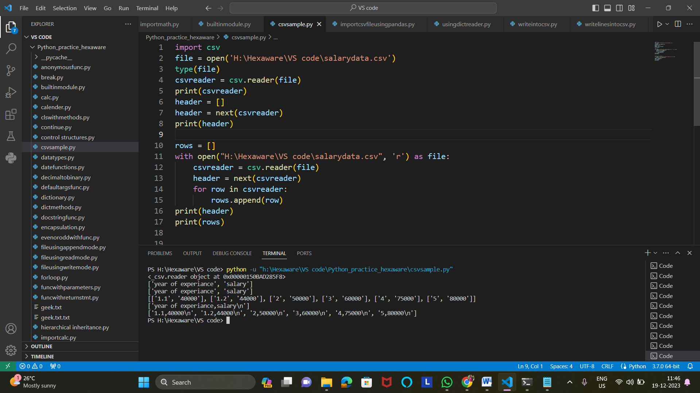

2)Writing the content into the csv file

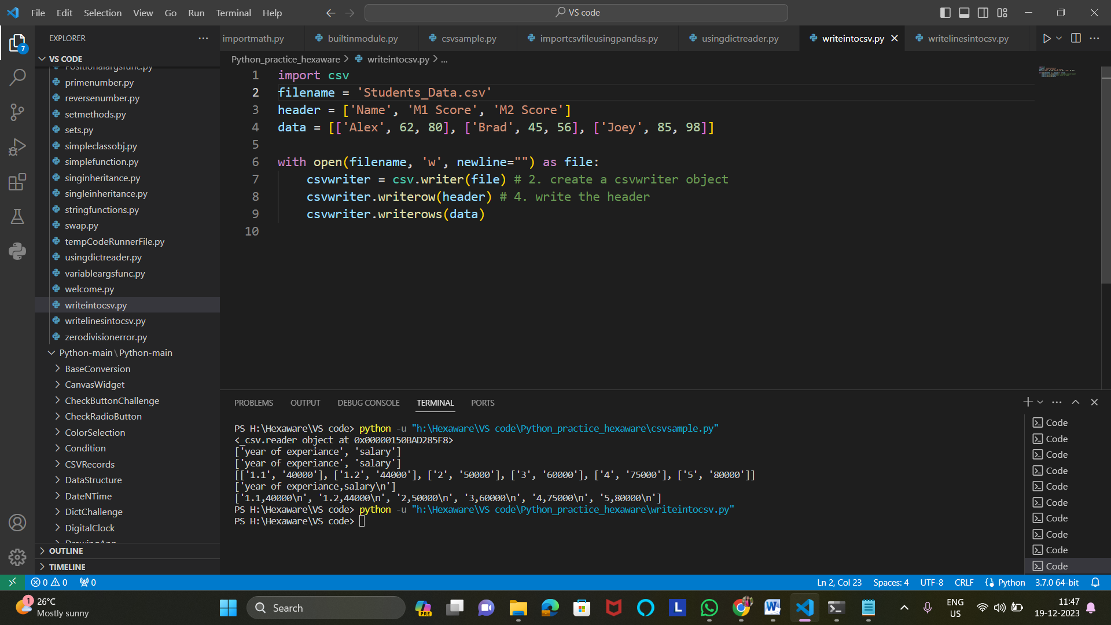

3)Accessing csv file using pandas

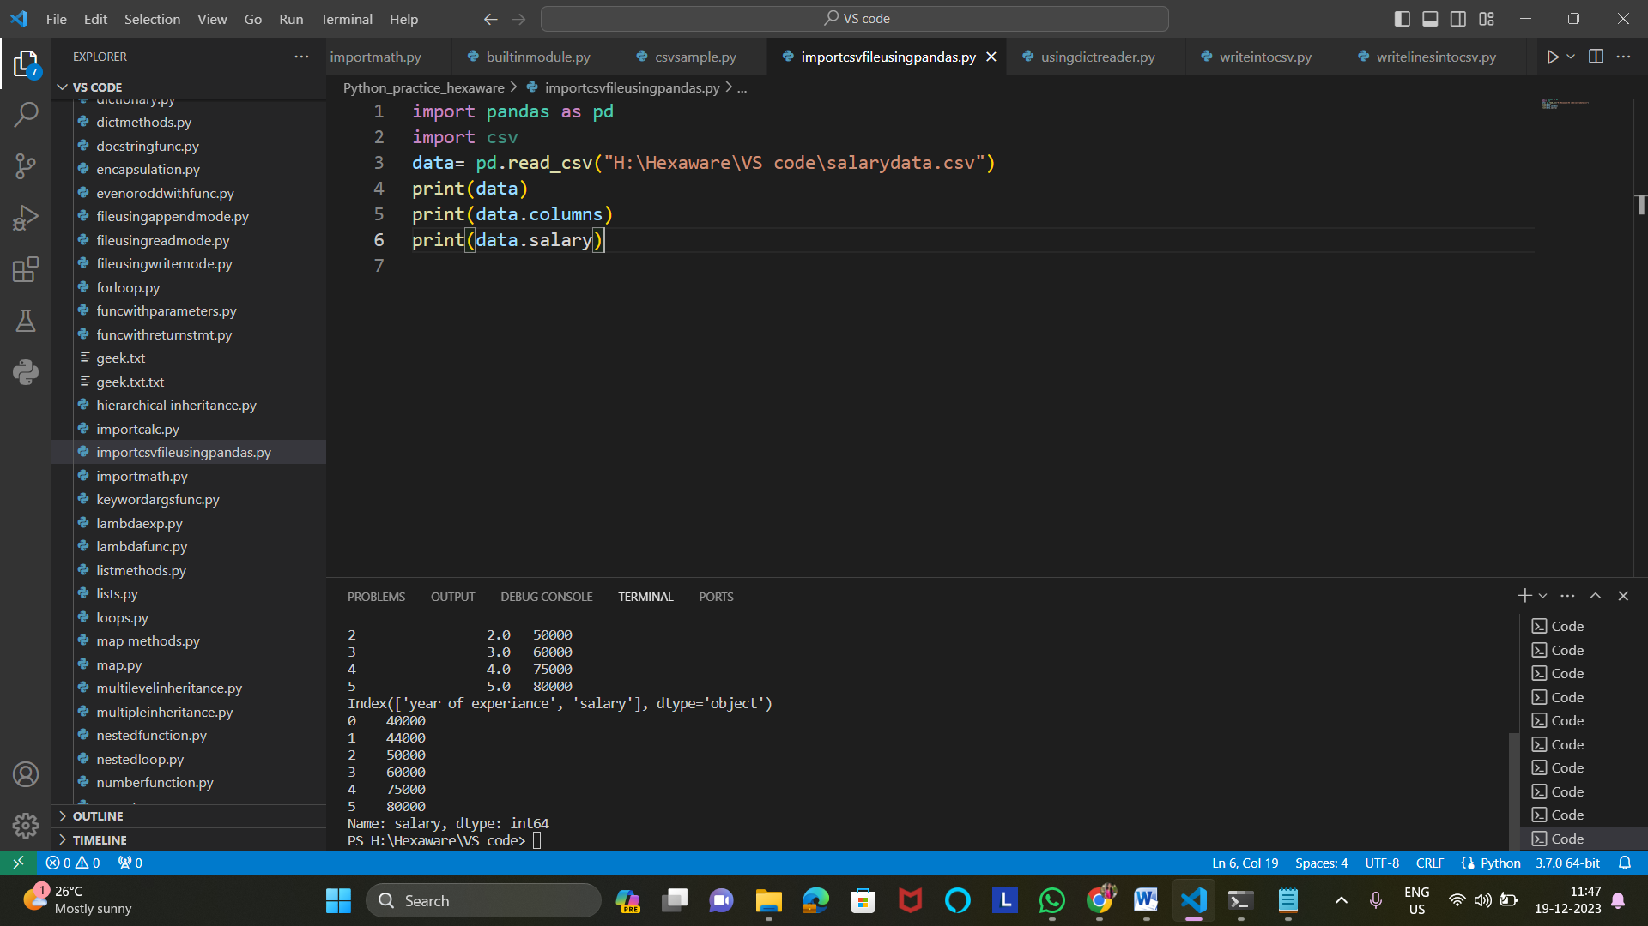

4)csv file reading using DictReader() method

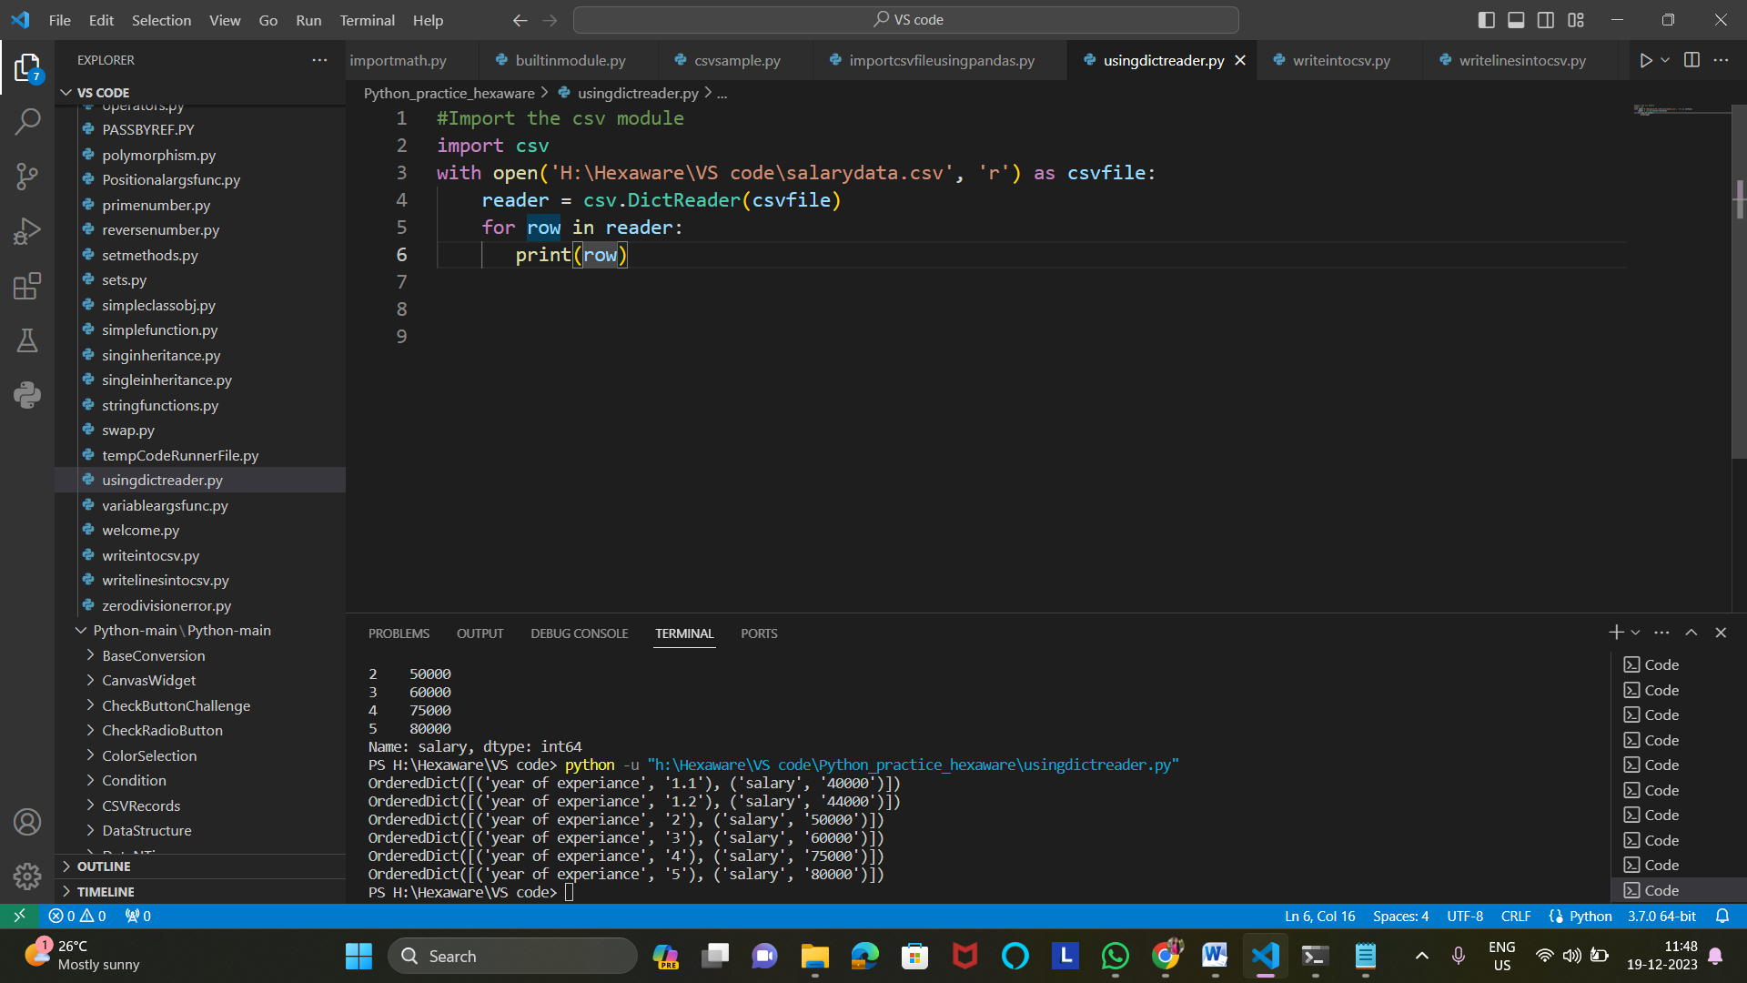

5)Writing list of data into the csv file

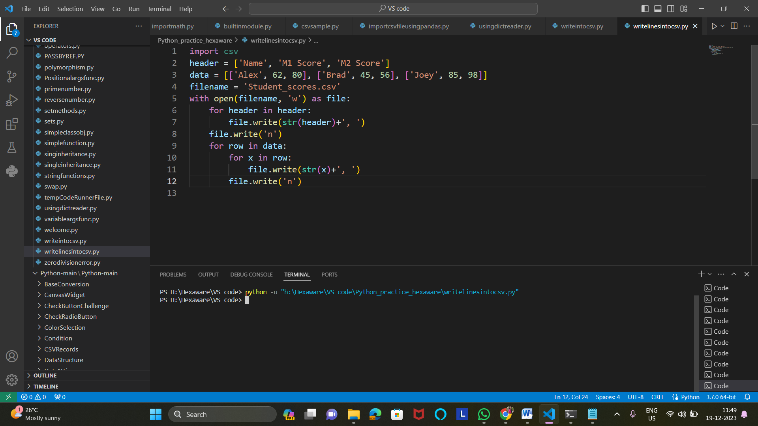

6)Writing into csv file using pandas

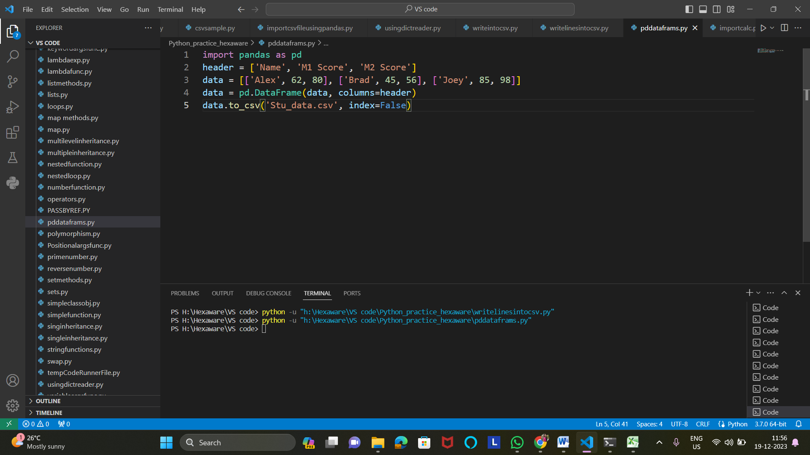

7)Writing into csv file using Dictwriter() method

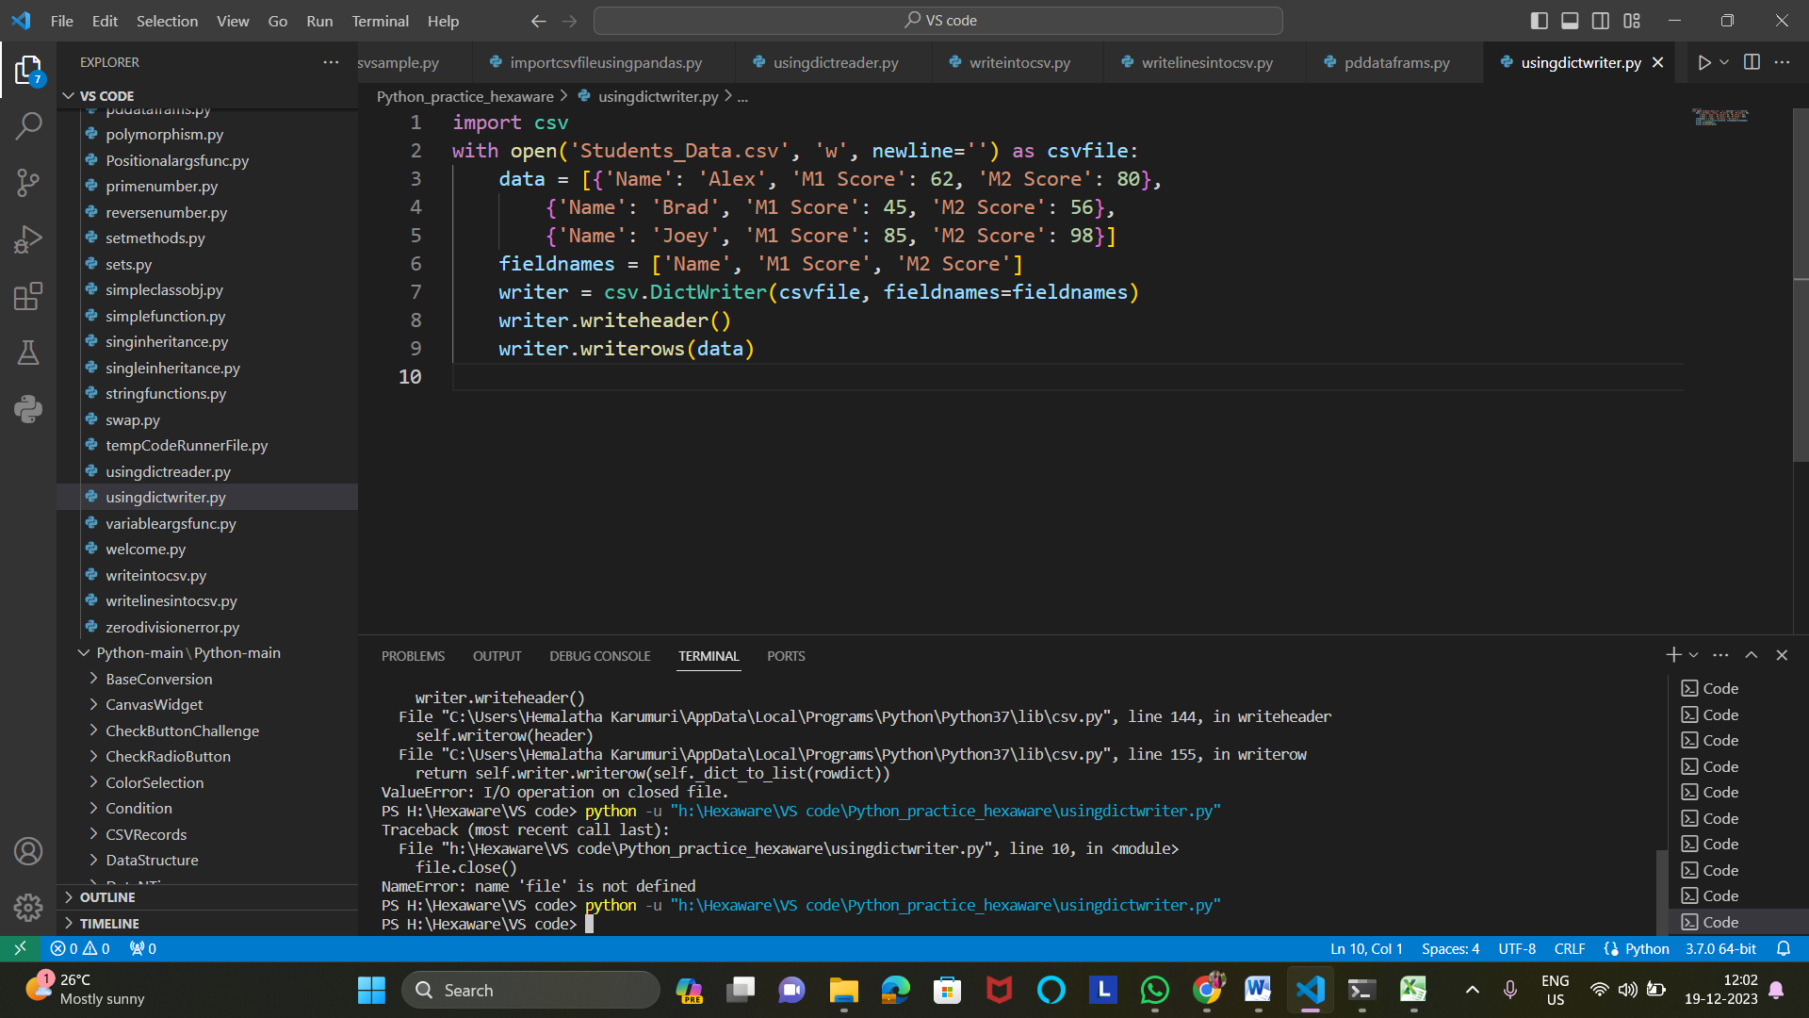

8)Convert JSON String to Dictionary Python

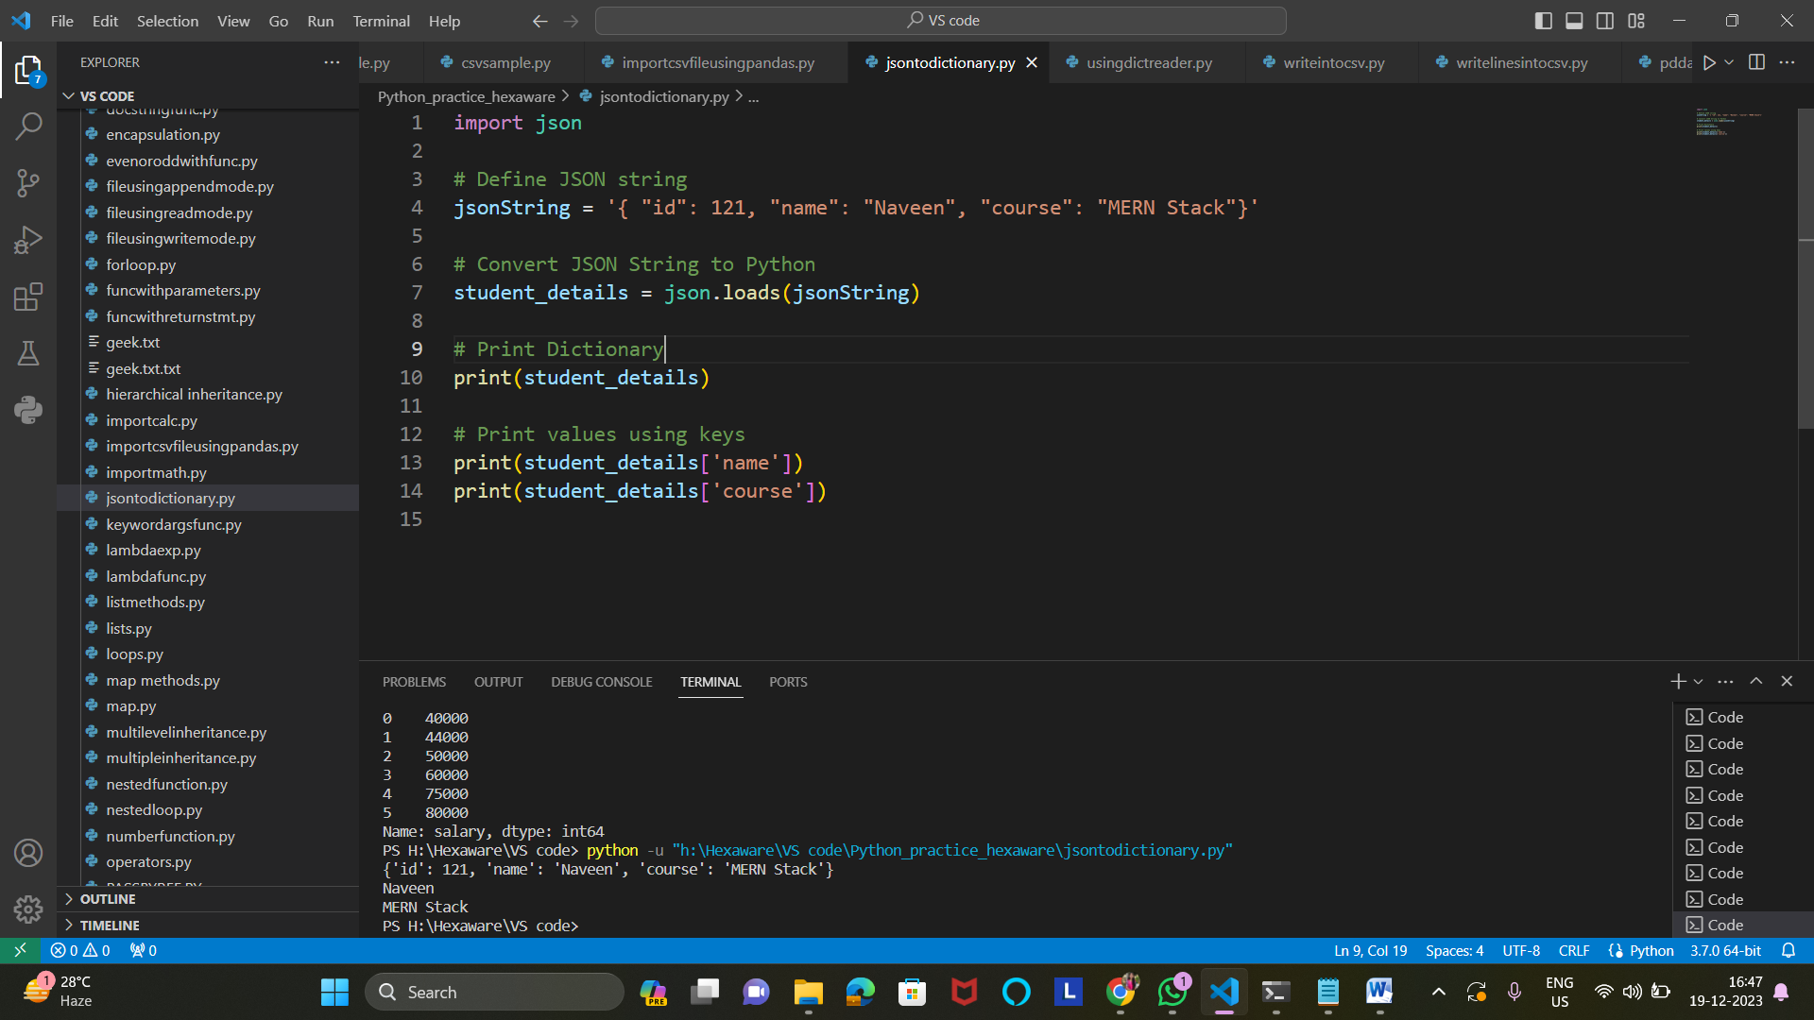

9)Convert JSON File to Python Object

